Contents
Running the python program 2
MySQL Workbench – Final transposed records with json contents 2
Json file under nested folder structure 3

Code

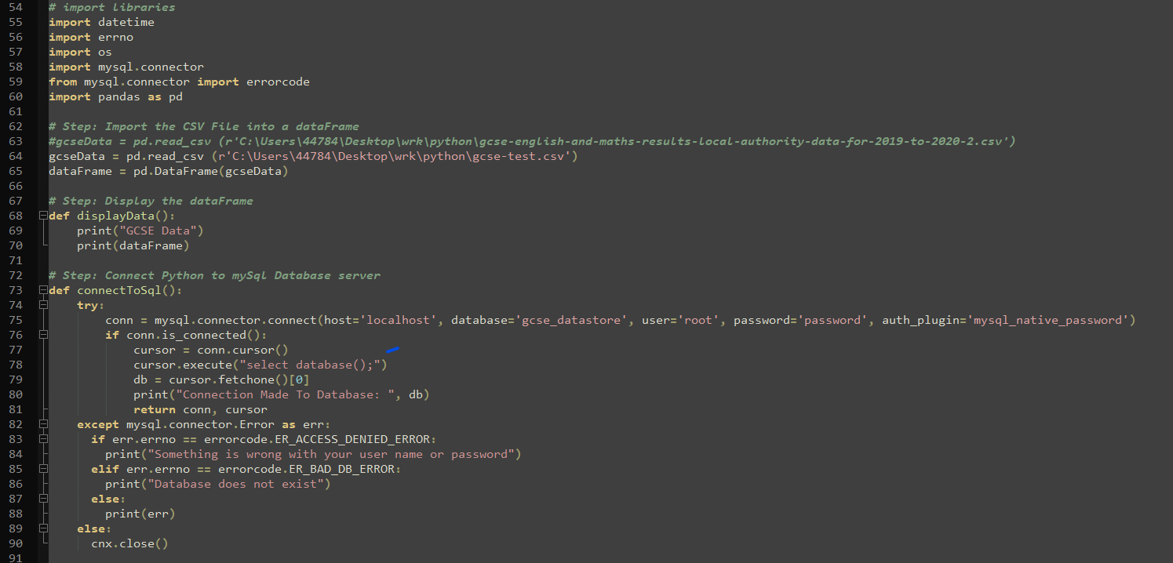

Running the python program

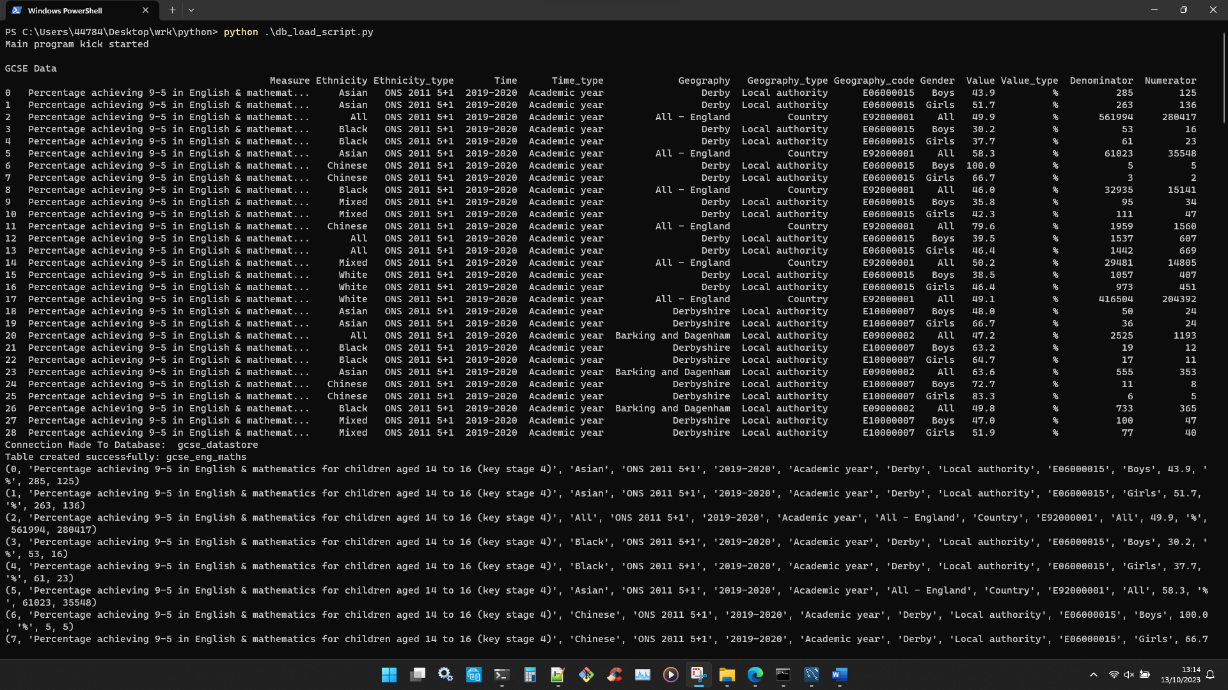

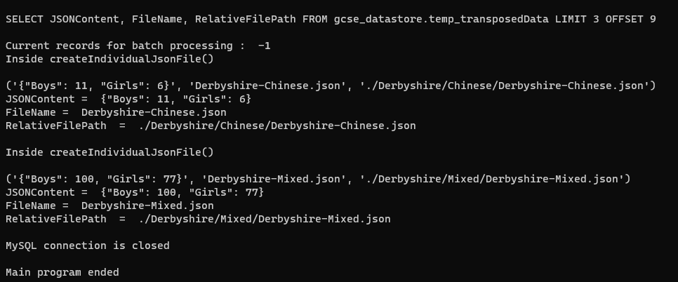

MySQL Workbench – Final transposed records with json contents

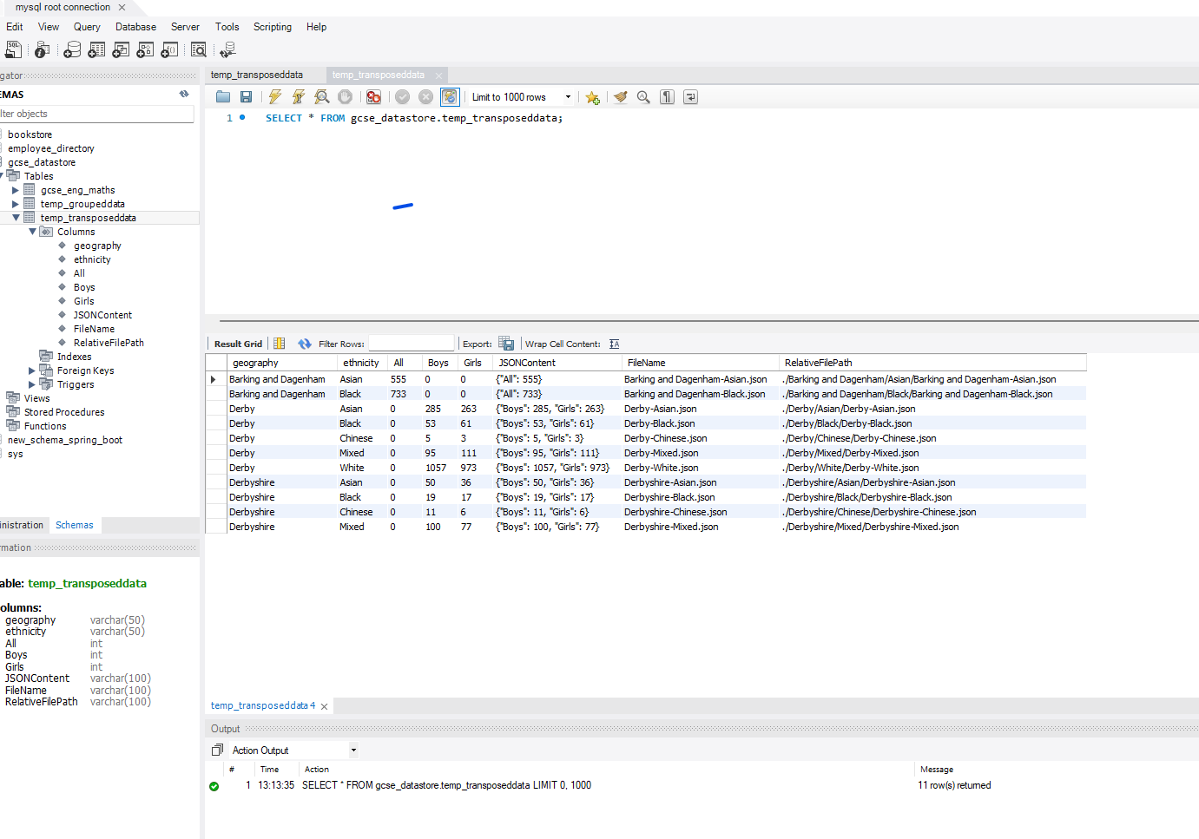

Json file under nested folder structure

